19.08.2021. Today I studied two topics:

* CSS Counters
* CSS Website Layout

And did a good practice improvised. There is a beauty saloon located in Jumeirah Al Naseem called “Mrs B”. I created a tiny website with 3 basic layout in it. I did a header with logo on the left side and with the slogan on the right. And below the header goes the content. Content part is divided to 3 horizontally equal columns. First contains little information about a mission of a beauty lounge. Second is in the middle and displays the picture from the lounge and third column has information about branches. And finally at the end we have footer with some contact information and some legal details about the company. All of the links are active meaning that you can directly click to a displayed email address and it will open your default mail application with the address of the company. And by clicking on the phone number you can call it straight away. Also on the right side of the footer you can see the links to the Instagram and facebook accounts of the beauty lounge and it will redirect you there in a new page.

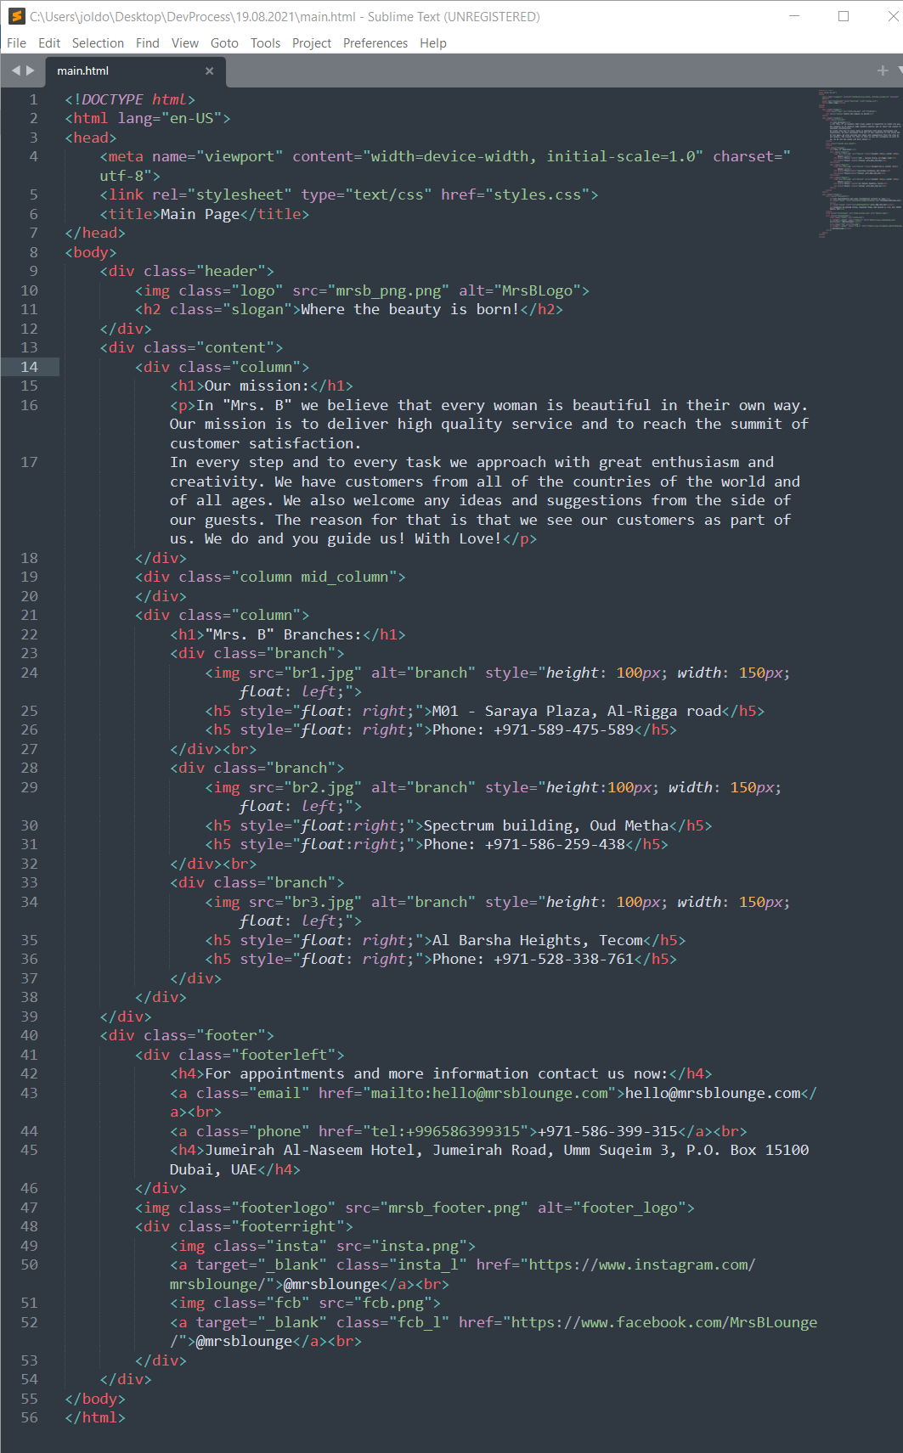

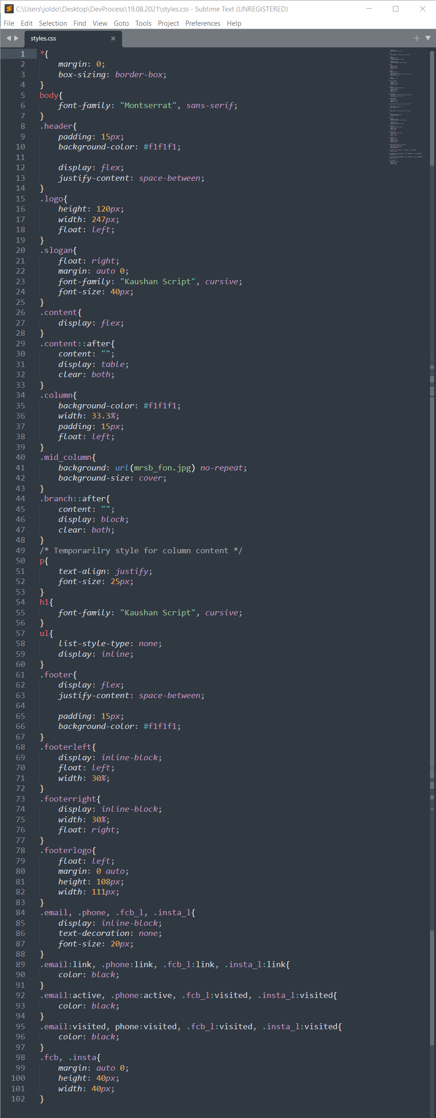

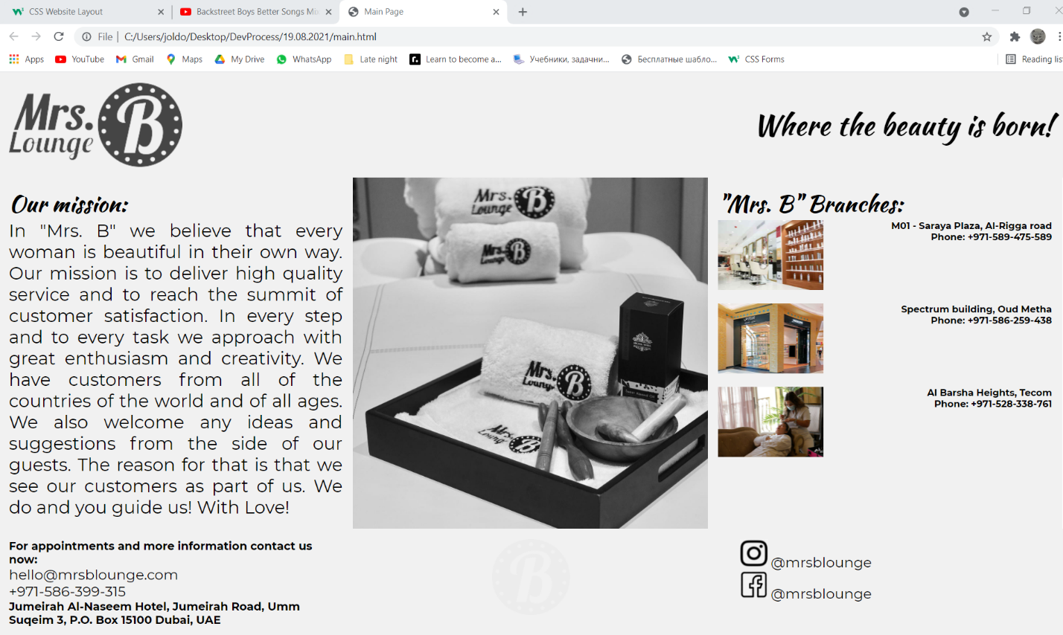

This is the look of my webpage.